Sprint 2 Report

**Team Members:** Austin Wentz and Jordan Doell

**Date:** November 1, 2012

**Class:**  Senior Design

**Subject:** Sprint 2 Report

**Sponsor:** L-3: June Alexander-Knight

# Backlog

## Completed

* Purchase and configure single board computer (SBC) to act as high –level controller
* Purchase SSR pcb kit, SSR heat sinks, and Renard microcontroller pcb kit
* Analysis and research for design and requirements for project
* Start learning iOS development
* Assemble additional circuitry (SSR and Renard kits)
* Implement Renard serial protocol
* Purchase Christmas lights
* Purchase extension cords
* Develop prototype which switches lights on and off using predefined sequence
* iPhone app prototype

## Remaining

* Design display case for electronic components
* Have the display case made and assembled.
* Program and configure Raspberry Pi to act as midi sequencer for lights
* Develop and implement iPhone app which controls the Christmas lights

# iOS Application progress:

Jordan Doell

During Sprint 2, I have been continuing to learn Objective-C and iOS application development. I found and have been watching a podcast that covers iOS development and Objective-C. Also, James has been lecturing to me and Josh about iOS and some of the components we will need for the project. We still have a few more lectures to go, but we are making progress.

# App Prototype:

I have gained enough knowledge of iOS so far to make a simple prototype. It is nonfunctional so far, but gives a little direction to where we are headed with the app. Below are some screenshots of the different views in the app.

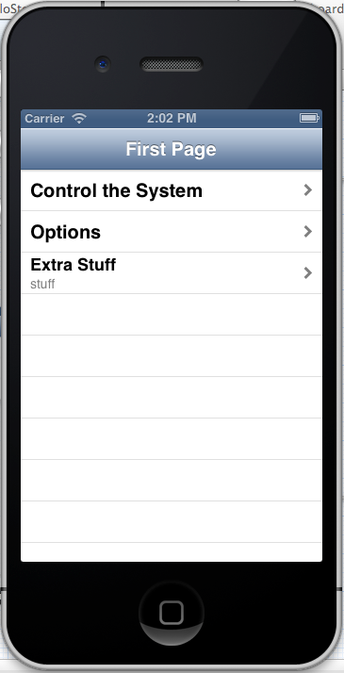

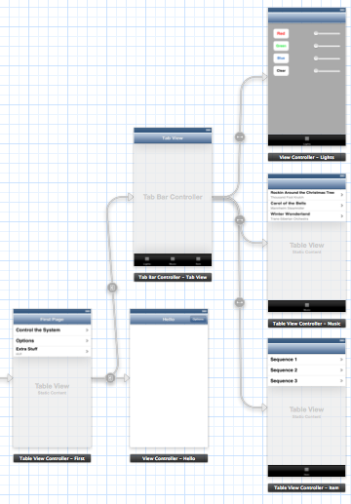

Fig. 1: Overall storyboard for the prototype Fig. 2: Main page of the app

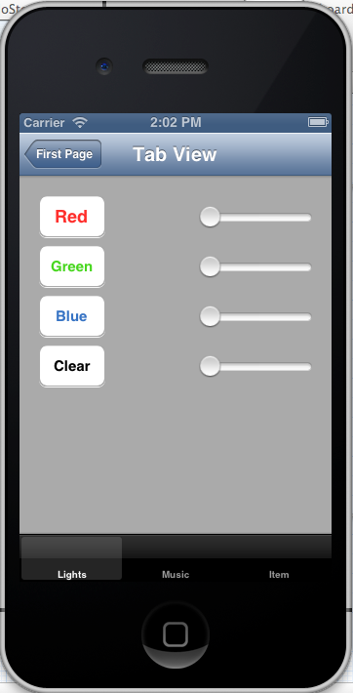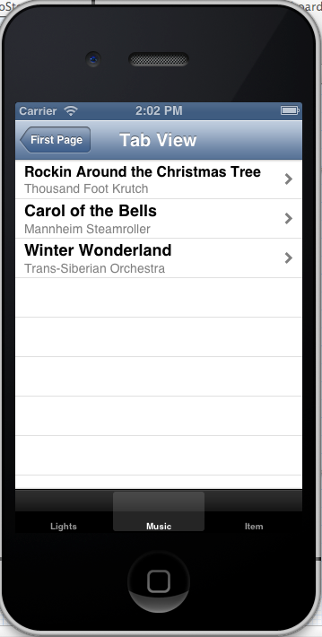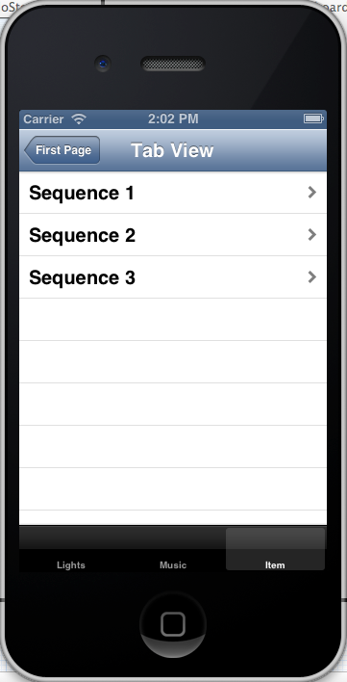

Fig. 3,4,5: Lights tab, Music tab, and Sequences tab

# Christmas Light Controller Progress

Austin Wentz

Considerable progress has been made on the hardware front. The Renard 64XC and the 8 SSRez’s are now soldered and thoroughly tested. In total, the soldering took 20-25 hours. Testing took another 5 hours to complete. With the hardware assembled, I put together a simple prototype which turns lights on and off using a predefined sequence. Several short videos are available to demo the prototype.

## Display Case

I have also been working on a design for a display case which houses the hardware. The dimensions of the case will be 16.5 inches x 16.5 inches x 12 inches. Here are some initial requirements for the case:

* Safety features – Renard 64XC and SSRez’s will only be powered when lid is closed.
* Locking mechanism to prevent theft
* Made of acrylic
* Fan for keeping SSR’s cool
* Cord management